Coding Lions

**Team:**

Anton Konstanvinov Babev (VIII G)

Ivelin Petkov Voynov (VIII V)

Stefan Diqnov Radev (VIII Б)

Mihail Atanasov Nikolov (VIII А)

**Project Objective:**

With each passing day, technologies are advancing rapidly, and this includes robotics as well. There are various types of robots with different purposes that assist humans in almost everything one can imagine. The goal of our website is to provide information to users about robotics. It covers topics such as types of robots, their uses, and achievements in the field of technology.

**Project Stages:**

After forming the team, we started adding different folders to our virtual space, such as style, HTML, and content, to organize the files we would be using. Once we completed this, we began creating a navigation bar that would divide the information into different links. Shortly after, we had a group meeting where we exchanged ideas for the website. That's when we started shaping the website. Initially, we used black and gray as the color scheme, but later we used coolors.co to choose a more pleasant color.

Initially, we used this color scheme:

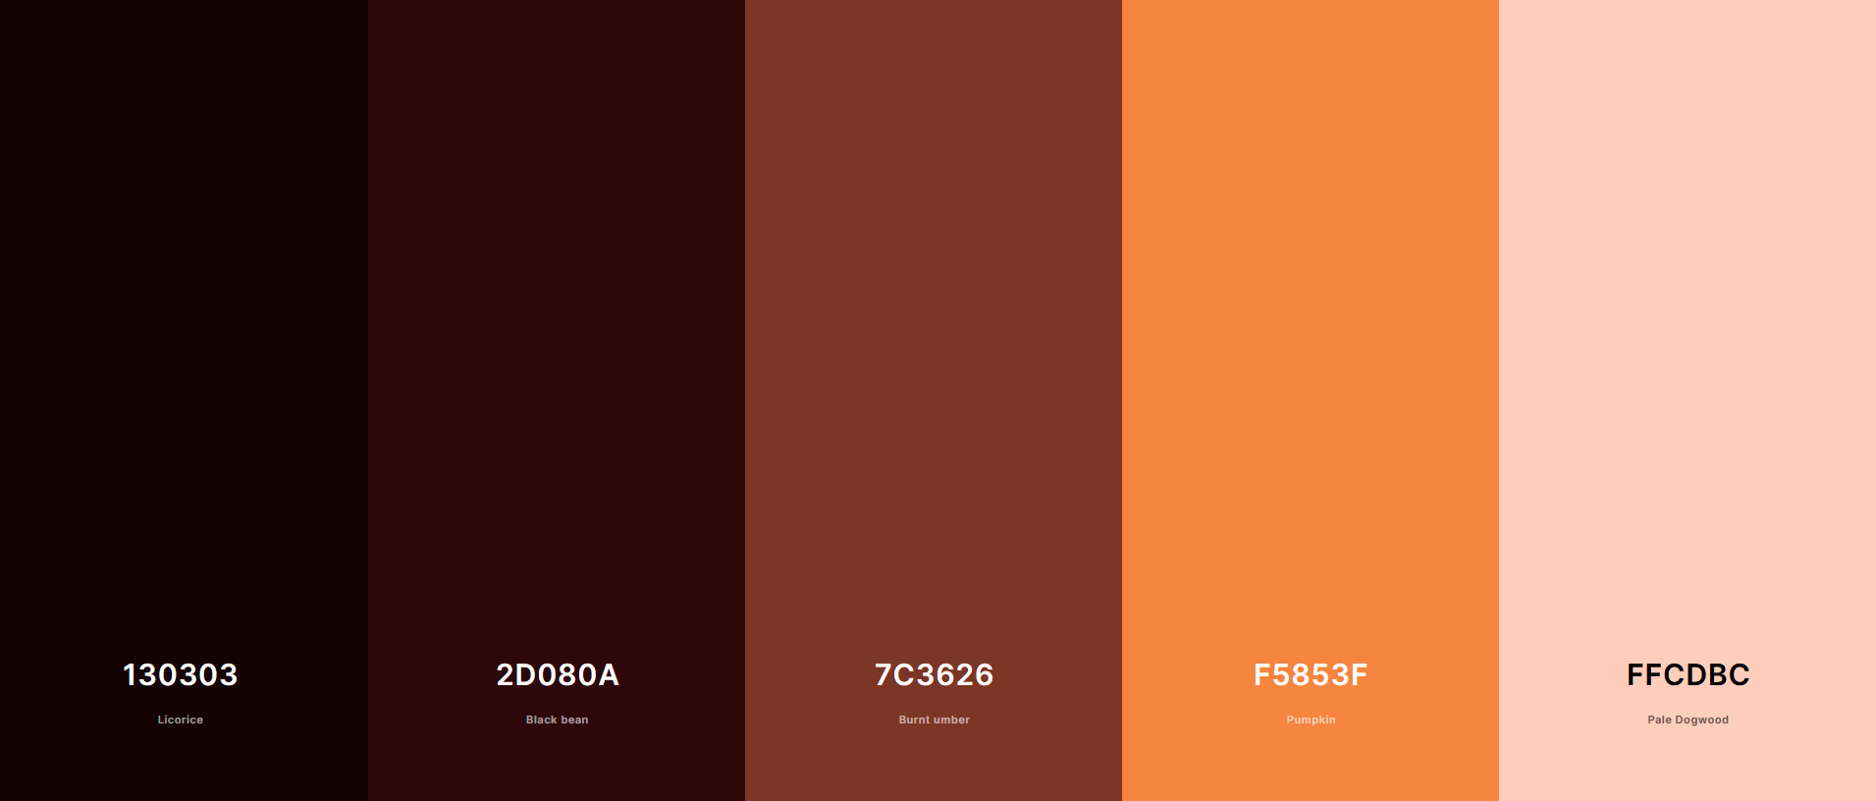

But when we applied it, some people didn't like it, so we changed it to this:

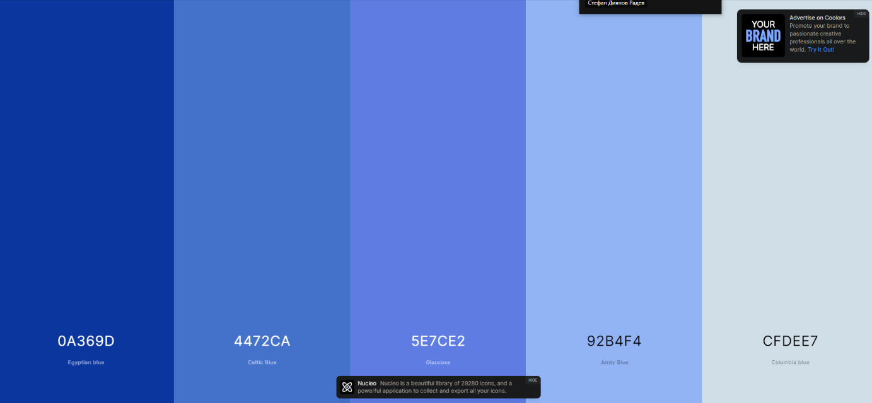

After finishing the website design, we started adding photos and information to it. Finally, we added the team's logo to the website.

**Conclusion**

Once we completed everything, we ended up with a user information website with a nice design. The website can certainly be improved with JavaScript, HTML, and CSS for more advanced features, which will turn it into a better source of information.